

EXPORT PROGRAM – LINUX BASICS 01

October 4, 2017

ALBERTO ARAM RASCÓN GARCÍA

SYSTEMS ENGINEER

EPAM SYSTEM MEXICO.

[www.epam.com](http://www.epam.com/)

CONTENTS

1. USER CONFIGURATION 3

1.1. Create use with sudo privileges 3

1.2. Password configuration 5

1.3. Password expiration 5

1.4. SSH key generation 6

1.5. Transfer ssh key to another server 6

1.6. Log in to another server 7

2. LVM CONFIGURATION 8

2.1. Basic partitioning 8

2.2. Physical volumes 9

2.3. Volume groups 10

2.4. Logical volumes 10

2.5. Volume group resizing 10

2.6. Formatting the partition 11

2.7. Mounting the partition 11

Appendix A. PROOFS OF FUNCTIONALITY 13

Appendix A.1. SUDO command should not ask for password 13

Appendix A.2. User password should be at least 8 characters 13

Appendix A.3. Log into another server using ssh keys 13

Appendix A.4. LVM’s size 13

# USER CONFIGURATION

## Create use with sudo privileges

Our current user doesn’t have admin privileges, so we’ll create a new one, first we become root with the **su** command:

$ su

Password:

#

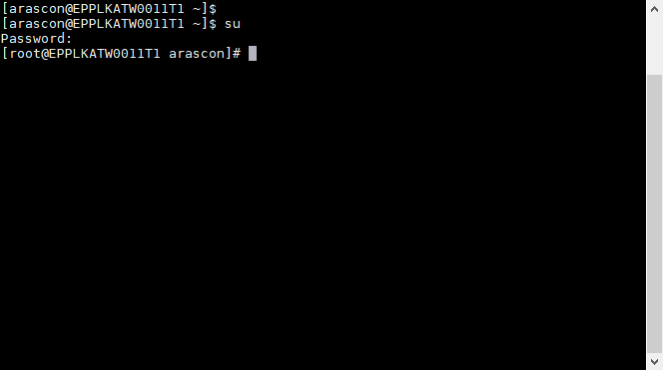

Then we’ll use the **adduser** utility to create the user linux-basics01 and later this user will be added to the wheel group. By default on CentOS members of the **wheel** group have sudo privileges.

# adduser linux-basics-01

# usermod –aG wheel linux-basics-01

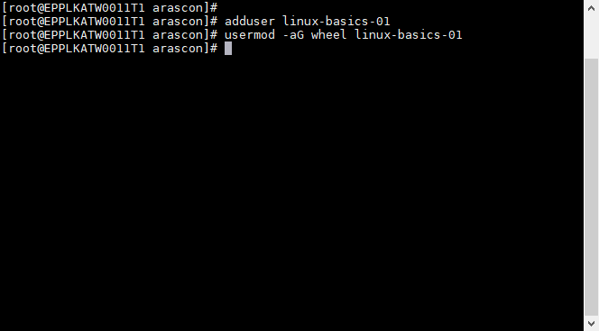

Rinse and repeat for the user on the second VM:

# adduser linux-basics-02

# usermod –aG wheel linux-basics-02

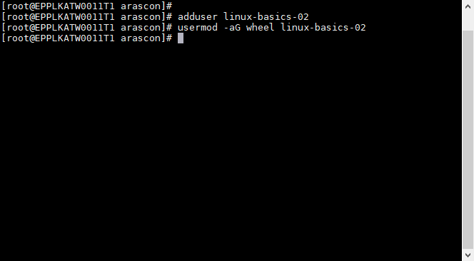

For additional commodity we’ll enable passwordless sudo, in order to accomplish this, the **visudo** utility will become handy adding the following line to the end of the file:

linux-basics-01 ALL=(ALL) NOPASSWD: ALL

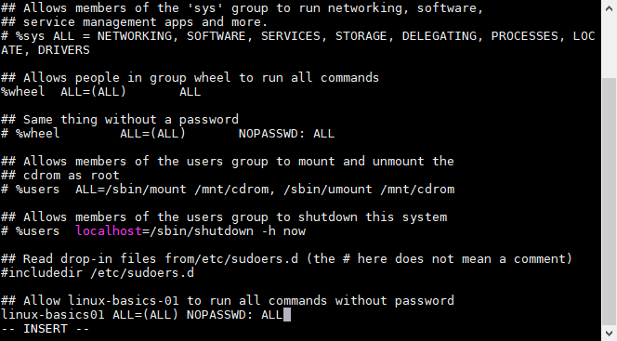

The same line should be added for the second VM:

linux-basics-02 ALL=(ALL) NOPASSWD: ALL

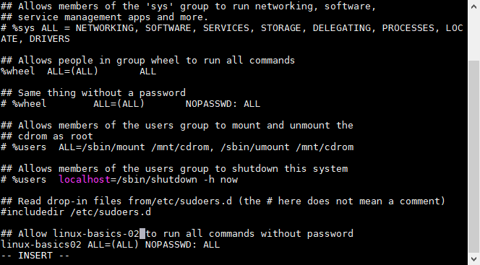

## Password configuration

The password policy established for this lab includes a minimum password length of 8 characters, for this we’ll use the **pam_pwquality** module, the configuration of this module is locate in **/etc/security/pwquality.conf** we’ll need to edit this file:

# vi /etc/security/pwquality.conf

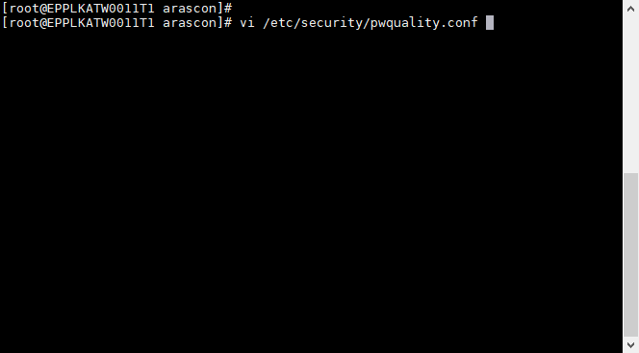

Inside this file we’ll add or comment out the line with the minlen clause and set it to 8:

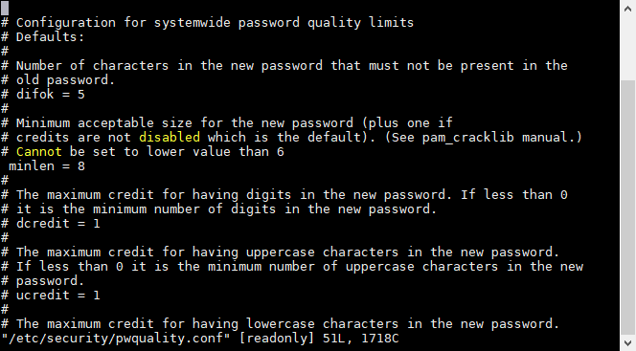

## Password expiration

In order to set an expiration date every X days we’ll use the **chage** utility with the option **–d** to set the number of days:

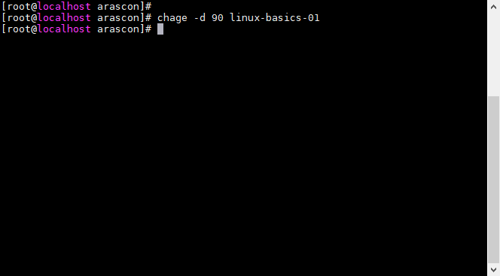

## SSH key generation

It’s very convenient to create ssh keys if we’re going to access others servers with frequency, for this step we’re going to use ssh-keygen:

$ ssh-keygen

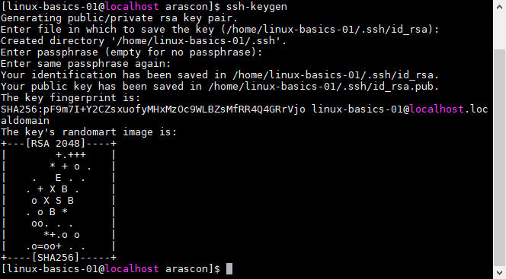

## Transfer ssh key to another server

We can use our new ssh key to loggin to another server using our public key, before that we’ll need to copy this public key to our remote server using **ssh-copy-id**:

$ ssh-copy-id linux-basics-02@10.0.2.15

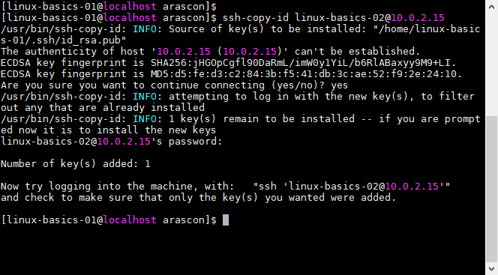

## Log in to another server

We’ll ensure we can log into the other server using our ssh key:

$ ssh linux-basics-02@10.0.2.15

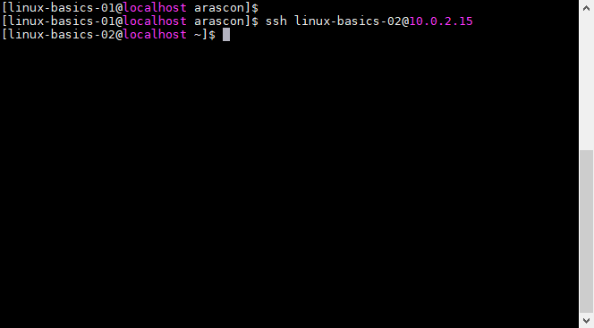

# LVM CONFIGURATION

## Basic partitioning

In case we don’t know the name of the device that we’ll be using we can check it out with the **lsblk** utility:

# lsblk

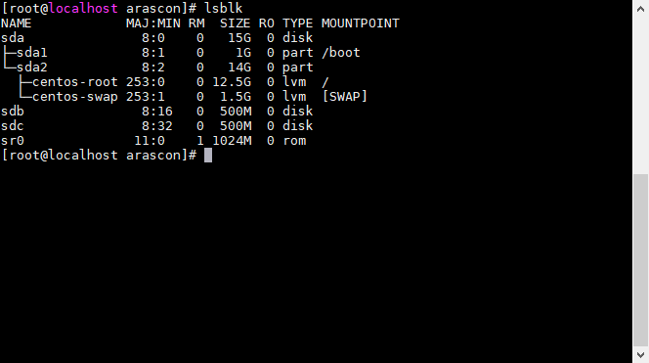

In this case **sdb** and **sdc** are the devices that we’ll be using for our lvm, in order to create a partition **fdisk** it’s an option for this job, the first parameter being the device name, on the following prompt we’ll introduce the **n** option to create a new partition, **p** for creating a primary partition type, **1** to start from the very beginning, **+100M** to indicate that our partition will be 100MB size and **w** to confirm our changes and write them to the disk

# fdisk /dev/sdb

n

p

1

+100M

w

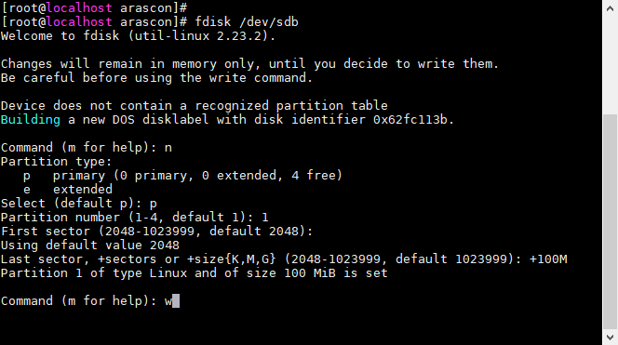

We’ll be repeating the same steps for the second partition on the next device:

# fdisk /dev/sdc

n

p

1

+100M

w

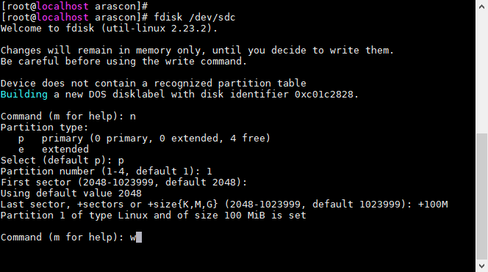

## Physical volumes

After we partitioned our devices we can create our physical volumes with **pvcreate**:

# pvcreate /dev/sdb1

# pvcreate /dev/sdc1

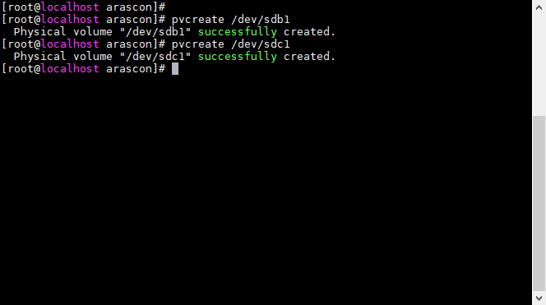

## Volume groups

The syntax for creating a volume group its **vgcreate** followed by the name we’ll be giving to the volume group and then all the physical volume we want to include.

# vgcreate basics-lvm /dev/sdb1 /dev/sdc1

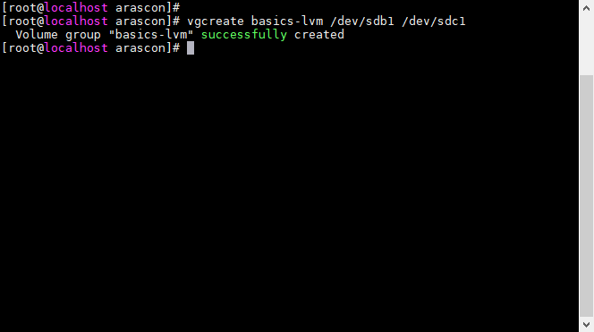

## Logical volumes

We’ll be creating a logical volume that uses the remaining space with the **lvcreate** utility followed by the n flag and the name we want to give to our logical volume and then the size of our volume and finally the name of our volume group.

# lvcreate -n my-lvm1 --size 100M basics-lvm

# lvcreate -n my-lvm2 --size 100M basics-lvm

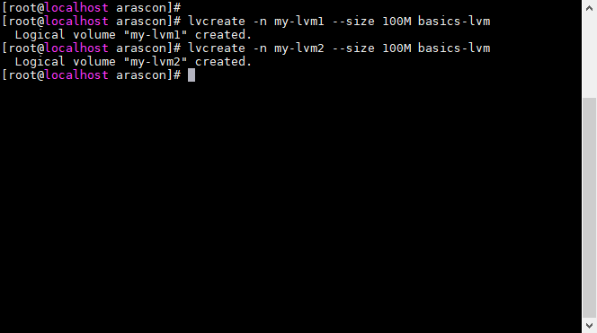

## Volume group resizing

If we want to check our volume sizes we can use the lvs tool:

# lvs

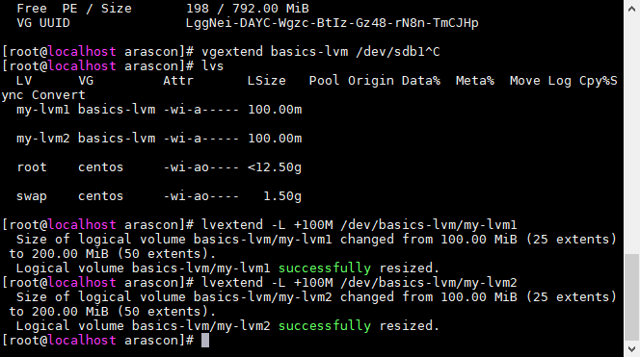

In order to resize our volume group, first we’ll be resizing our logic volume first with the **lvextend** utility passing the length we want to increase as a parameter:



## Formatting the partition

In order for our LVM to be useful we’re going to set a format for this partition, in this case it will be xfs:

# mkfs.xfs /dev/basics-lvm/my-lvm1

# mkfs.xfs /dev/basics-lvm/my-lvm2

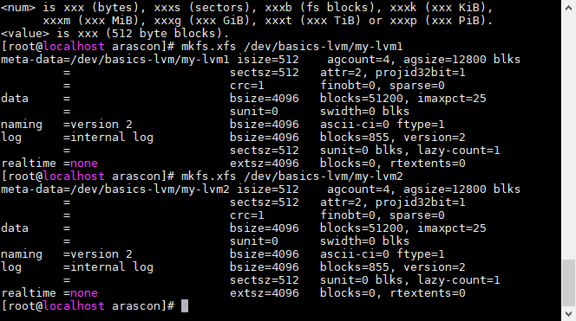

## Mounting the partition

Whenever we want to mount a device we will need a mounting point in this case we’re going to create a folder for our lvm1 and lvm2 in /opt:

# mkdir /opt/lvm1

# mkdir /opt/lvm2

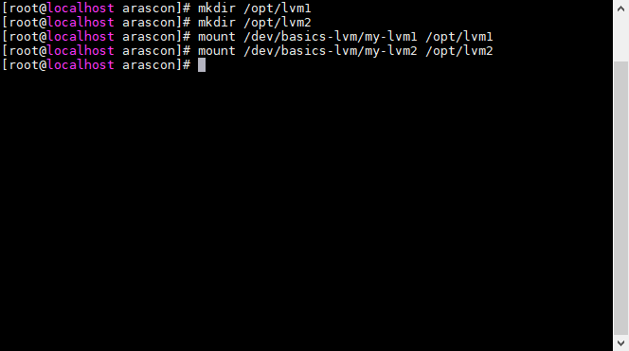

Finally, we just mount our device to the given mounting point:

# mount /dev/basics-lvm/my-lvm1 /opt/lvm1

# mount /dev/basics-lvm/my-lvm2 /opt/lvm2



1. PROOFS OF FUNCTIONALITY

This section contains all the proofs of functionality for this lab.

* 1. SUDO command should not ask for password

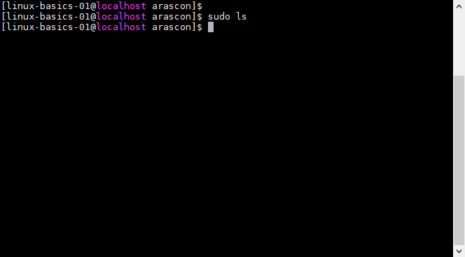

* 1. User password should be at least 8 characters

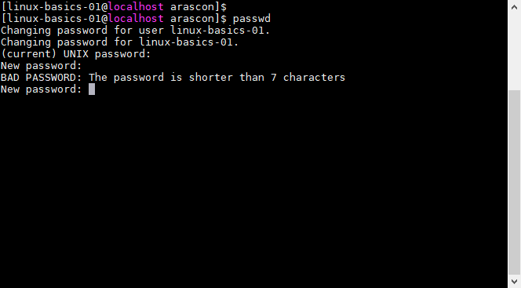

* 1. Log into another server using ssh keys



* 1. LVM’s size

The output for df –h is the following:

